Christian Schmitt
Concert Organist and Educator
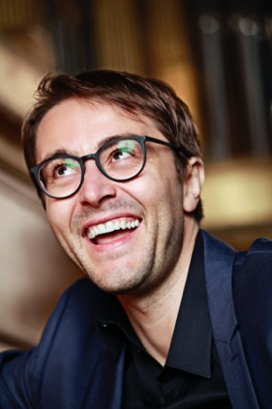
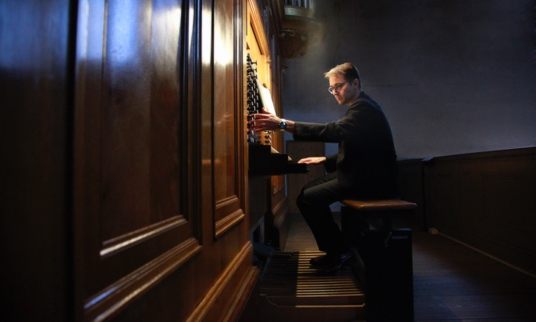
© Uwe Arens
“Schmitt found colours to marvel at.”
(Wiener Zeitung)
Since his debut with the Berlin Philharmonic under the baton of Sir Simon Rattle and the Salzburg Festival with Magdalena Kožená, Christian Schmitt has been one of the most sought-after organists internationally. In the 22/23 season he will make his debuts at Carnegie Hall New York under Dennis Russel Davis, with the Dallas Symphony and with the Gothenburg Symphony under Christoph Eschenbach. In 2021/22 he was "Artist in Focus" of the Tonhalle Orchestra Zurich as well as curator of the "International Organ Days" there and inaugurated the new organ under the direction of Paavo Järvi. Since 2014 he has been Principal Organist of the Bamberg Symphony Orchestra, for which he curates the organ series for the Bamberg Concert Hall.
Recent highlights include his debut at Walt Disney Concert Hall presented by the Los Angeles Philharmonic, performances with the Staatskapelle Berlin conducted by Daniel Barenboim, the Japanese premiere of Toshio Hosokawa's "Embrace - Light and Shadow" with the Tokyo Metropolitan Symphony Orchestra at Suntory Hall, and the release of his most recent recording of Hindemith’s Kammermusik No. 7 with conductor Christoph Eschenbach.
Christian Schmitt has played the organs of the Elbphilharmonie Hamburg, the Konzerthaus Berlin, the Berlin Philharmonie, the Vienna Musikverein, the Gewandhaus Leipzig and the Maison Symphonique Montréal, and has collaborated with conductors and soloists such as Juliane Banse, Sibylla Rubens, Matthias Goerne, Thomas Hampson, Philippe Herreweghe, Manfred Honeck, Matthias Höfs, Jakub Hruša, Marek Janowski, Cornelius Meister and Michael Volle.

Christian Schmitt's discography currently includes around 40 recordings. For Deutsche Grammophon, Schmitt recorded two CDs for the project 'Bach 333 - Die neue Gesamtausgabe'. Equally noteworthy is the album 'Prayer' with Magdalena Kožená, released by Deutsche Grammophon in 2014.
In 2013, the organist was awarded an ECHO Klassik for his recording of Widor's organ symphonies opp. 42.3 and 69. A passionate educator, Christian is a guest lecturer at universities worldwide. Since the winter semester of 2021, he has been teaching at Codarts University Rotterdam as Organ Professor and successor to Ben van Oostens. Christian Schmitt studied organ with Daniel Roth (Paris), Leo Krämer (Saarbrücken) and James David Christie (Boston).
He is an expert consultant for organ renovations and new construction of organs in Berlin, Nuremberg, Zurich, Lucerne and Brno. His latest project is a digitally sampled version of the organ of the Philharmonie Essen for concerts with and in orchestra’s. The digital version of the famous organ, created in cooperation with a Dutch acoustics company, is transportable and easily adaptable to hall size and needs. Christian Schmitt has been a member of numerous international music competition juries and is involved in the music education project Rhapsody in School.
© Dorn Music, January 2023
This approved biography is not to be altered or shortened without the management’s permission.

Website
www.christianschmitt.info
Contact
www.christianschmitt.info/kontakt

